# **How To Outsource Digital Marketing**

In the ever-evolving business landscape, the digitalization of marketing strategies has become an indispensable tool. For companies seeking to enhance their online presence while focusing on core operations, outsourcing digital marketing has emerged as a practical solution.

In 2021, 70% of businesses increased their digital marketing budget, with [78% of them opting to outsource part or all of their strategies](https://www.statista.com/statistics/1274437/digital-marketing-budget-worldwide/), according to a research conducted by Statista. In this article, we will discuss what is Digital Marketing and how a businesses could outsource digital marketing services.

## **Understanding Digital Marketing**

As we venture into the realm of outsourcing digital marketing, a vital step precedes the process - understanding the components and breadth of digital marketing. Simply put, digital marketing is a multifaceted approach that utilizes digital channels to connect with and engage consumers. These channels extend across a broad spectrum and include social media platforms, search engines, email systems, and various websites.

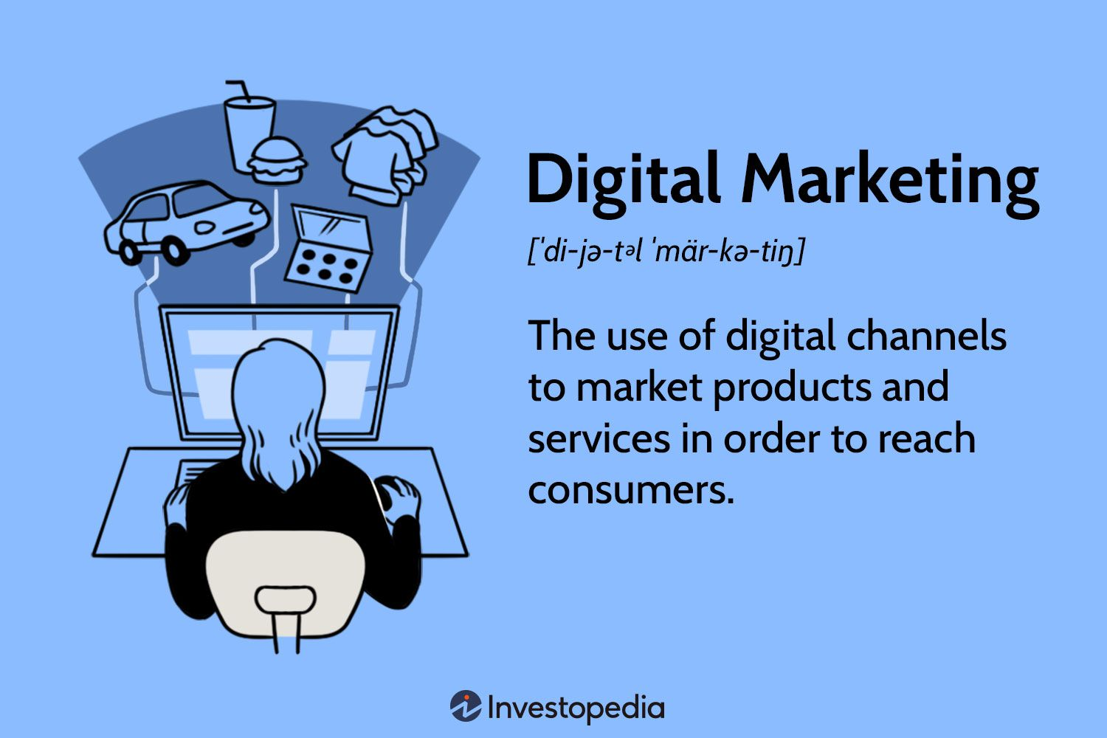

[Source](https://www.investopedia.com/thmb/gVszoGBuWBrWopoa4vQ7S7ZCsBI=/1500x0/filters:no_upscale():max_bytes(150000):strip_icc()/Term-Definitions_Digital-Marketing-5ae6ea1aee934b02a94a1a4d9401443d.jpg)

Within the vast domain of digital marketing lie several strategies, each designed to target specific aspects of online consumer engagement. These strategies include Search Engine Optimization (SEO), which aims to increase a website's visibility on search engine result pages. Then there's content marketing, a strategic approach focused on creating and distributing valuable, relevant, and consistent content to attract a clearly defined audience. Social media marketing employs social media platforms to promote a product or service, while Pay-Per-Click (PPC) is an internet advertising model used to drive traffic to websites. Email marketing is another effective digital strategy that involves sending emails to prospects and customers to cultivate relationships and encourage customer loyalty.

According to a [2021 report by eMarketer](https://www.insiderintelligence.com/topics/topic/digital-ad-spending), the global expenditure on digital marketing campaigns was estimated at a whopping $455.30 billion. This staggering figure not only illustrates the magnitude of digital marketing but also underscores its potential to reach a global audience and revolutionize the way businesses connect with consumers. In the era of digital consumerism, understanding the vast landscape of digital marketing is a pivotal first step for any business aiming to outsource its digital marketing successfully.

## **Benefits of Outsourcing Digital Marketing**

Embracing the strategy of outsourcing digital marketing can present numerous critical benefits to organizations. These advantages are not one-dimensional; rather, they extend across various facets of business operations, promising significant impact:

### **Expertise and Experience**

A significant advantage of outsourcing is the opportunity to tap into the specialized skills and knowledge that digital marketing agencies possess. Digital marketing is an expansive field with several specialized areas, such as SEO, content marketing, email marketing, social media management, and PPC advertising. It's not feasible for most organizations, particularly small to mid-sized ones, to maintain in-house teams with this range of expertise.

Digital marketing agencies, on the other hand, are a rich reservoir of experts in all these areas. These specialists have a pulse on the latest digital marketing trends, strategies, and techniques, ensuring your business stays competitive. They bring a variety of experiences from various industries, giving them the ability to inject fresh, innovative perspectives into your business's marketing strategies.

By outsourcing your digital marketing needs, you gain access to a team of professionals who are completely immersed in the world of digital marketing. This dedicated expertise can help you tackle unique business challenges and drive your marketing efforts forward

### **Cost-Efficiency**

Building an in-house digital marketing team to handle your online marketing needs can be a sizable investment for any business. This process entails costs that extend beyond basic salaries, as recruitment, onboarding, training, and benefits packages all factor into the overall expenditure of maintaining an in-house team.

Recruitment, for starters, can be a time-consuming and costly process. You'd need to spend considerable resources to attract the right talent, conduct interviews, and select the best candidates for your digital marketing tasks. The costs associated with recruitment could be substantial, especially for roles that require a high level of expertise and experience.

Once you have your team on board, there's the essential factor of training and development. The digital marketing landscape evolves rapidly, making ongoing training and professional development crucial to keep your team updated with the latest strategies, tools, and best practices. This aspect signifies another significant expenditure, both in terms of money and time.

Furthermore, providing a competitive benefits package is essential in today's job market. Benefits such as health insurance, paid time off, and retirement contributions add to the overall cost of maintaining an in-house digital marketing team.

Considering all these factors, outsourcing your digital marketing needs to a marketing agency can be a cost-effective alternative. When you outsource, you essentially pay for the services you need when you need them, and this flexibility can result in substantial savings. Plus, you eliminate the need for a costly recruitment process, training and development expenses, and the provision of benefits.

Additionally, marketing agencies are composed of diverse experts who can handle a broad range of digital marketing tasks. With an agency, you essentially have access to an entire team of experts, from SEO specialists to social media managers, without bearing the costs of hiring each one individually. This team can seamlessly integrate with your existing operations, offering their specialized skills to enhance your online marketing efforts.

### **Time-Efficiency**

Outsourcing digital marketing services offers businesses the significant advantage of allowing their in-house marketing team to zero in on the company's core operations. By allocating online marketing tasks to outside experts, businesses can create a more efficient operational model and enhance productivity.

In many organizations, the marketing department is required to wear multiple hats, managing a wide array of responsibilities that go beyond digital marketing. When you decide to outsource your digital marketing needs, you essentially free up your internal team's time and resources. This allows them to concentrate on what they do best - whether that's focusing on overall marketing strategy, product development, customer relationships, or other critical operations. In doing so, you are likely to boost both efficiency and effectiveness within your team.

Outsourcing services to a team of digital marketing experts means you are entrusting your online marketing tasks to individuals who are specialists in their field. They are adept at staying on top of trends, learning new technologies, and adapting strategies in the dynamic world of digital marketing. This level of expertise and adaptability is crucial in today's digital landscape and could give your business the competitive edge it needs to stand out.

On the other hand, your in-house marketing team, now unburdened by the detailed and often time-consuming tasks of digital marketing, can focus on strengthening the company's core operations. They can devote more time to understanding the business's unique goals, conducting market research, and developing strategies that align with the company's overall vision.

Outsourcing internet marketing tasks also reduces the likelihood of your internal team becoming overwhelmed with the constant demands of maintaining an effective digital presence. This can lead to an improved work environment, higher job satisfaction, and ultimately, better retention rates within your team.

### **Access to Advanced Tools**

A significant benefit of digital marketing outsourcing is the access it provides to advanced tools and software that can significantly enhance your online marketing efforts. These sophisticated resources can often deliver superior results compared to more rudimentary methods typically employed by in-house teams.

Digital marketing agencies, by the nature of their work, invest heavily in cutting-edge technologies and platforms to help them deliver the best results for their clients. These can range from sophisticated analytics tools to advanced automation software, content creation platforms, and other specialized digital marketing applications. Such tools allow agencies to develop, implement, and manage marketing campaigns more efficiently, with greater precision and effectiveness.

Moreover, these advanced tools can provide in-depth insights and data, something that rudimentary in-house methods may struggle to deliver. For instance, using a comprehensive analytics platform, a digital marketing agency can track and monitor the performance of various marketing campaigns across multiple platforms in real time. They can then use these insights to adjust strategies, optimize campaigns, and ensure they are continually moving towards achieving the client's goals.

## **Steps to Outsourcing Digital Marketing**

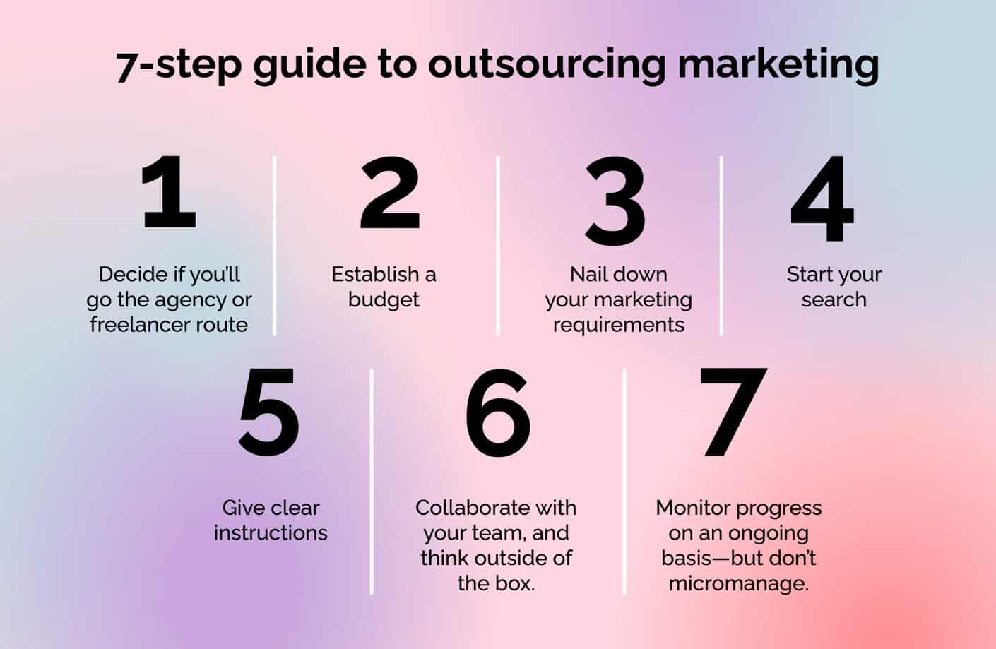

[Source](https://zenmedia.com/wp-content/uploads/2022/11/7-STEP-GUIDE__.jpg)

Now that we have covered the benefits, let's delve into how to outsource your digital marketing:

### **1. Define Your Marketing Goals**

Identify your goals before seeking an agency. Your goals might include increasing online sales, improving website traffic, or building brand awareness. Whether it's brand visibility, lead generation, or increased sales, your goals will guide your outsourcing decision. A survey found that businesses with clear, documented goals were [429% more likely to report success](https://coschedule.com/marketing-statistics).

### **2. Find the Right Agency**

When you're in the process of selecting a digital marketing agency, it's imperative to seek out one with a demonstrated history of success in achieving the type of goals you've established for your business. Their experience and proficiency in your specific industry should be a key consideration. It's also beneficial to review client testimonials, which can offer invaluable insights into the agency's capabilities and strengths.

An agency's past performance can provide a reliable indicator of how they might handle your specific needs. Have they consistently driven results for other businesses similar to yours? A proven track record of success can give you confidence in their ability to help you achieve your goals.

Experience within your specific industry is equally vital. Every industry has unique characteristics and challenges, and a digital marketing agency with relevant industry experience will be better equipped to navigate these nuances. They can draw upon their prior experiences to craft strategies that are specifically tailored to your industry, thereby increasing your chances of success.

In addition to their track record and industry experience, client testimonials can serve as a powerful tool for assessing an agency's credibility. These testimonials can provide firsthand insights into the agency's processes, the quality of their work, their ability to deliver on promises, and their commitment to client satisfaction.

### **3.Track and Review Performance**

Regularly assess the agency's performance using your predefined KPIs. In a 2021 report, companies that tracked their marketing performance were [17% more likely to achieve their business goals](https://coschedule.com/marketing-statistics).

### **4. Consider their Tools and Resources**

Make sure the agency uses up-to-date marketing tools and is aware of the latest marketing trends. A [2021 survey](https://www.hubspot.com/marketing-statistics) showed that 72% of successful marketers believe staying updated on technology is critical for marketing success.

### **5. Establish Communication and Reporting Processes**

Transparency and consistent communication form the backbone of a successful outsourcing partnership, particularly in the realm of digital marketing. Establishing a well-defined reporting structure is paramount to guarantee that you're consistently updated about the progress of your digital marketing initiatives.

Open and honest communication from the onset is crucial to ensure that both parties understand their roles, responsibilities, and expectations. Having regular touchpoints, whether they're daily, weekly, or monthly, can help maintain alignment between your business and the digital marketing agency. These regular updates can keep you informed about ongoing campaigns, potential challenges, and opportunities that the agency may have identified.

### **6. Collaborate on a Marketing Strategy**

Once you've chosen your agency, work with them to develop a robust digital marketing strategy. This should be a collaborative effort, combining the agency's expertise with your company's insights into its target audience and industry.

### **7. Discuss Budget and Pricing**

The agency should provide a clear, detailed quote for their services. A recent report revealed that 74% of companies consider cost transparency as a critical factor in their choice of a digital marketing agency.

## **Considering the Risks**

While outsourcing digital marketing can provide significant benefits, it's not without risks. For instance, a mismatch in expectations and communication breakdowns can lead to unsuccessful campaigns. Therefore, it's critical to select an agency that understands your business and can communicate effectively.

## **All in All**

Outsourcing digital marketing is a strategic move for businesses aiming to maximize their online presence and achieve their marketing goals more efficiently. By understanding your needs, selecting the right agency, and continually monitoring your campaigns, outsourcing can deliver powerful results, propelling your business to new heights in the digital space.

The world of digital marketing is dynamic and expansive. By outsourcing, companies can tap into expert knowledge and innovative tools to navigate this landscape effectively. Remember, the success of your digital marketing efforts is tied to your choice of agency. So, take the time to choose wisely.